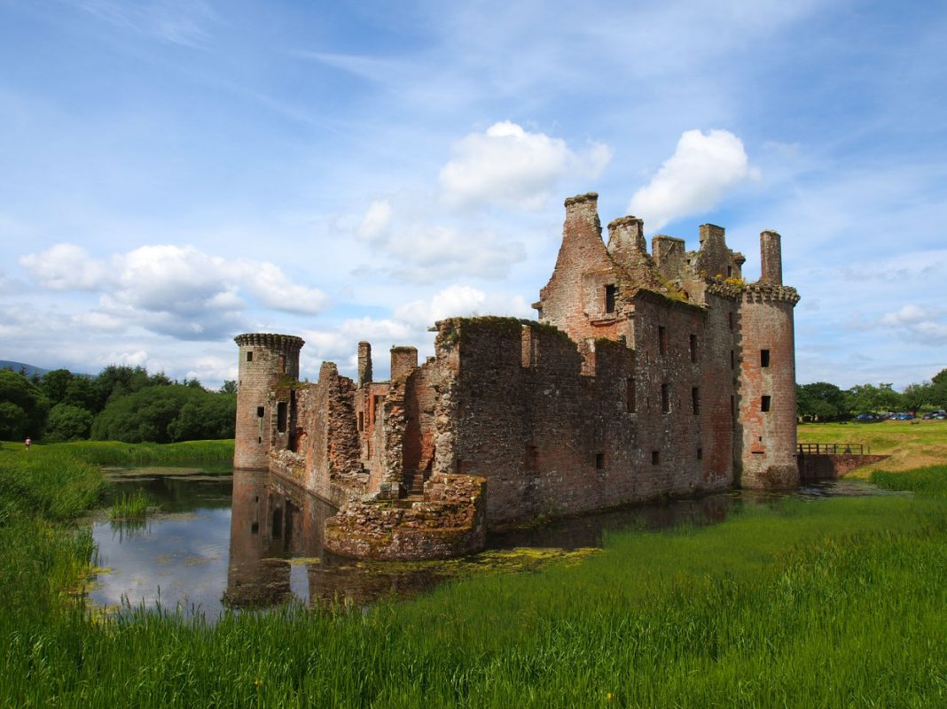

|  |
| --- |
| D&G tourism  User Guide |
|  |
| May 27 2019  D&G Tourism  Authored by: Charlie Harris |

# Using the website – Introduction

|  |
| --- |
| Using your new website stress free. Congratulations on your new website. Within this guide you will find helpful tips to get the most out of your website, and to ensure that all staff associated with this site, understand fully what they are doing. |
| The website has 3 main pages. HOME. PLACES. CONTACT. All of these are accessible from the Home screen. |
| The website navigation bar is located at the top. To navigate to any other page on this website, simply click the heading at the top of the screen.  The website automatically resizes itself depending on the screen size it is on, with the buttons big enough to click on small mobile devices.  Using the website - Home  To get started right away with your website, Just load the website up, which will then launch you onto the home screen. This is the beginning of the website, all navigation can be handled from this page.  The home page is the central hub. From this page you can navigate to the places & contact us pages. The page feature the map of the county, as well as a brief introduction to who D&G Tourism is as a company.    *Navigation*  *bar*  *Map* |

Using the website – Places

When you click on the Places button on the navigation bar, you will be greeted with a page featuring buttons of each location that was chosen. For example, if you click the word Dumfries, you will be navigated to the Dumfries page. The specific location pages are only accessible from the Places page itself and not from the Home or Contact page.

Using the website – Locations

Each unique place page features the coordinates, an image, as well as facts, History and statistics of that area. To navigate back to the places page, simply click places on the navigation bar.

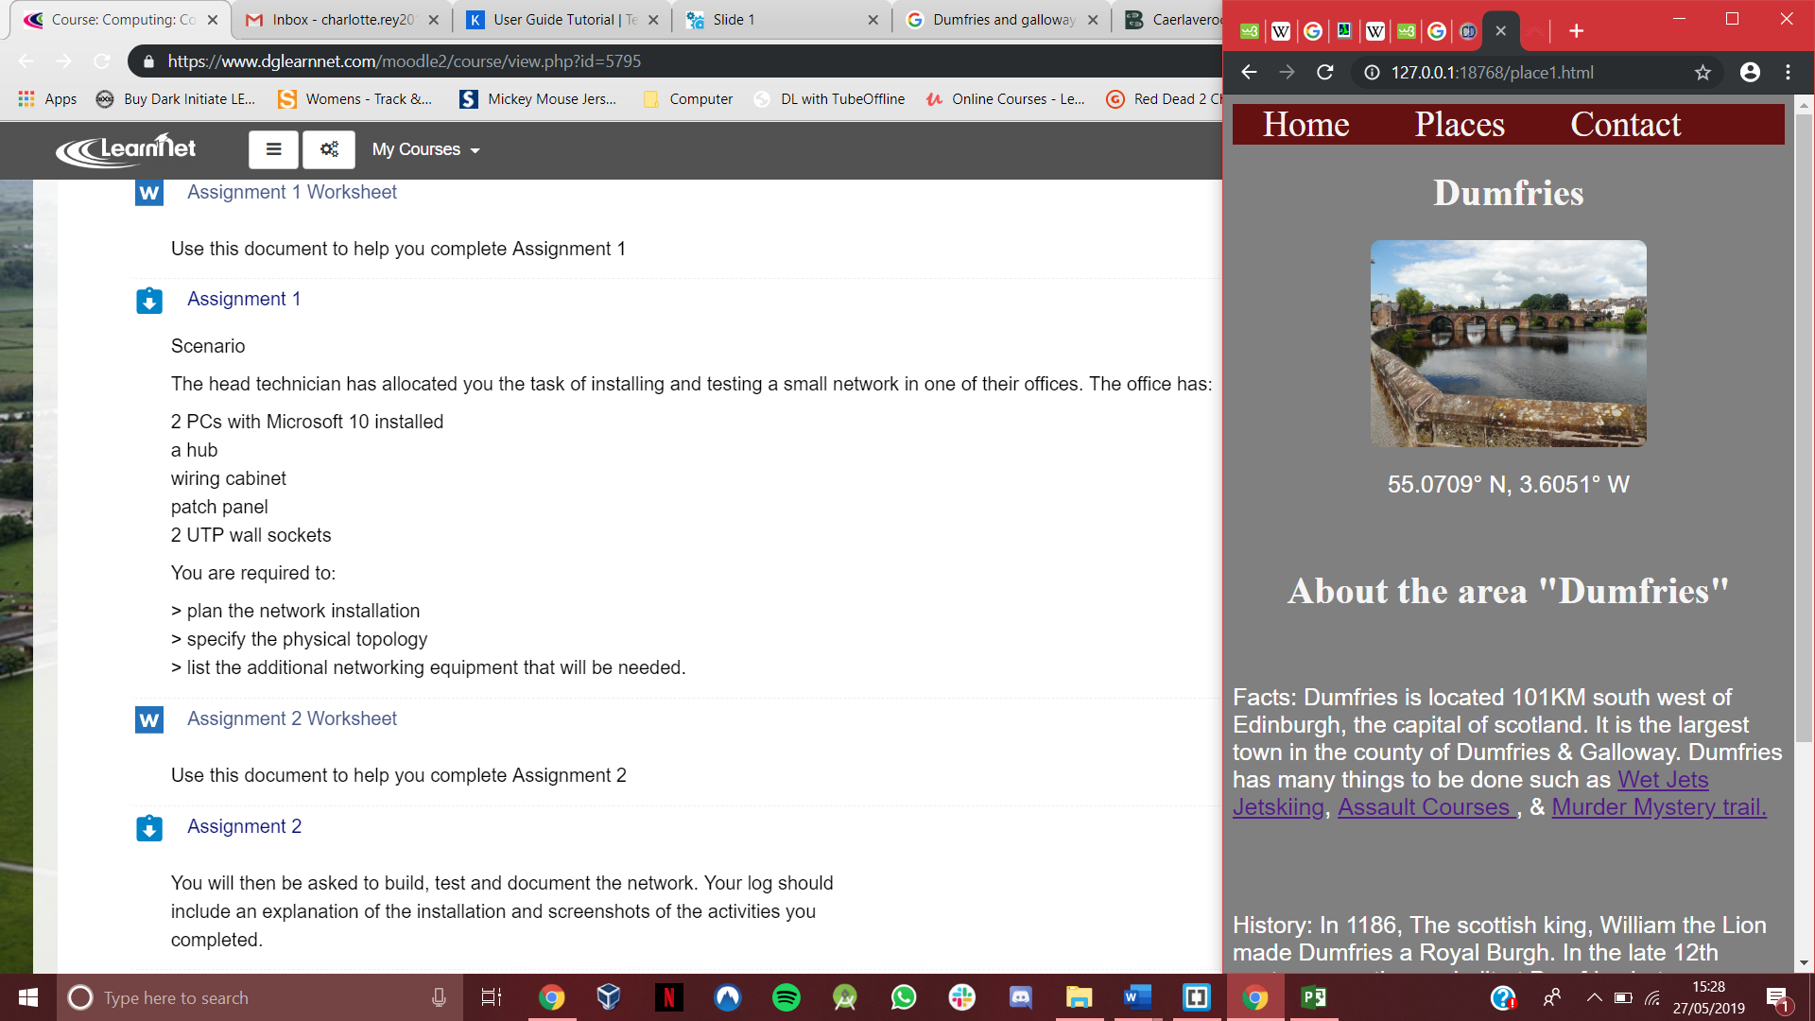

*Navigation*

*bar*

Using the website – Contact

On the contact page you will find the information for your **CLIENTS** to contact **YOU**. The Email and contact number are both provided on this page.

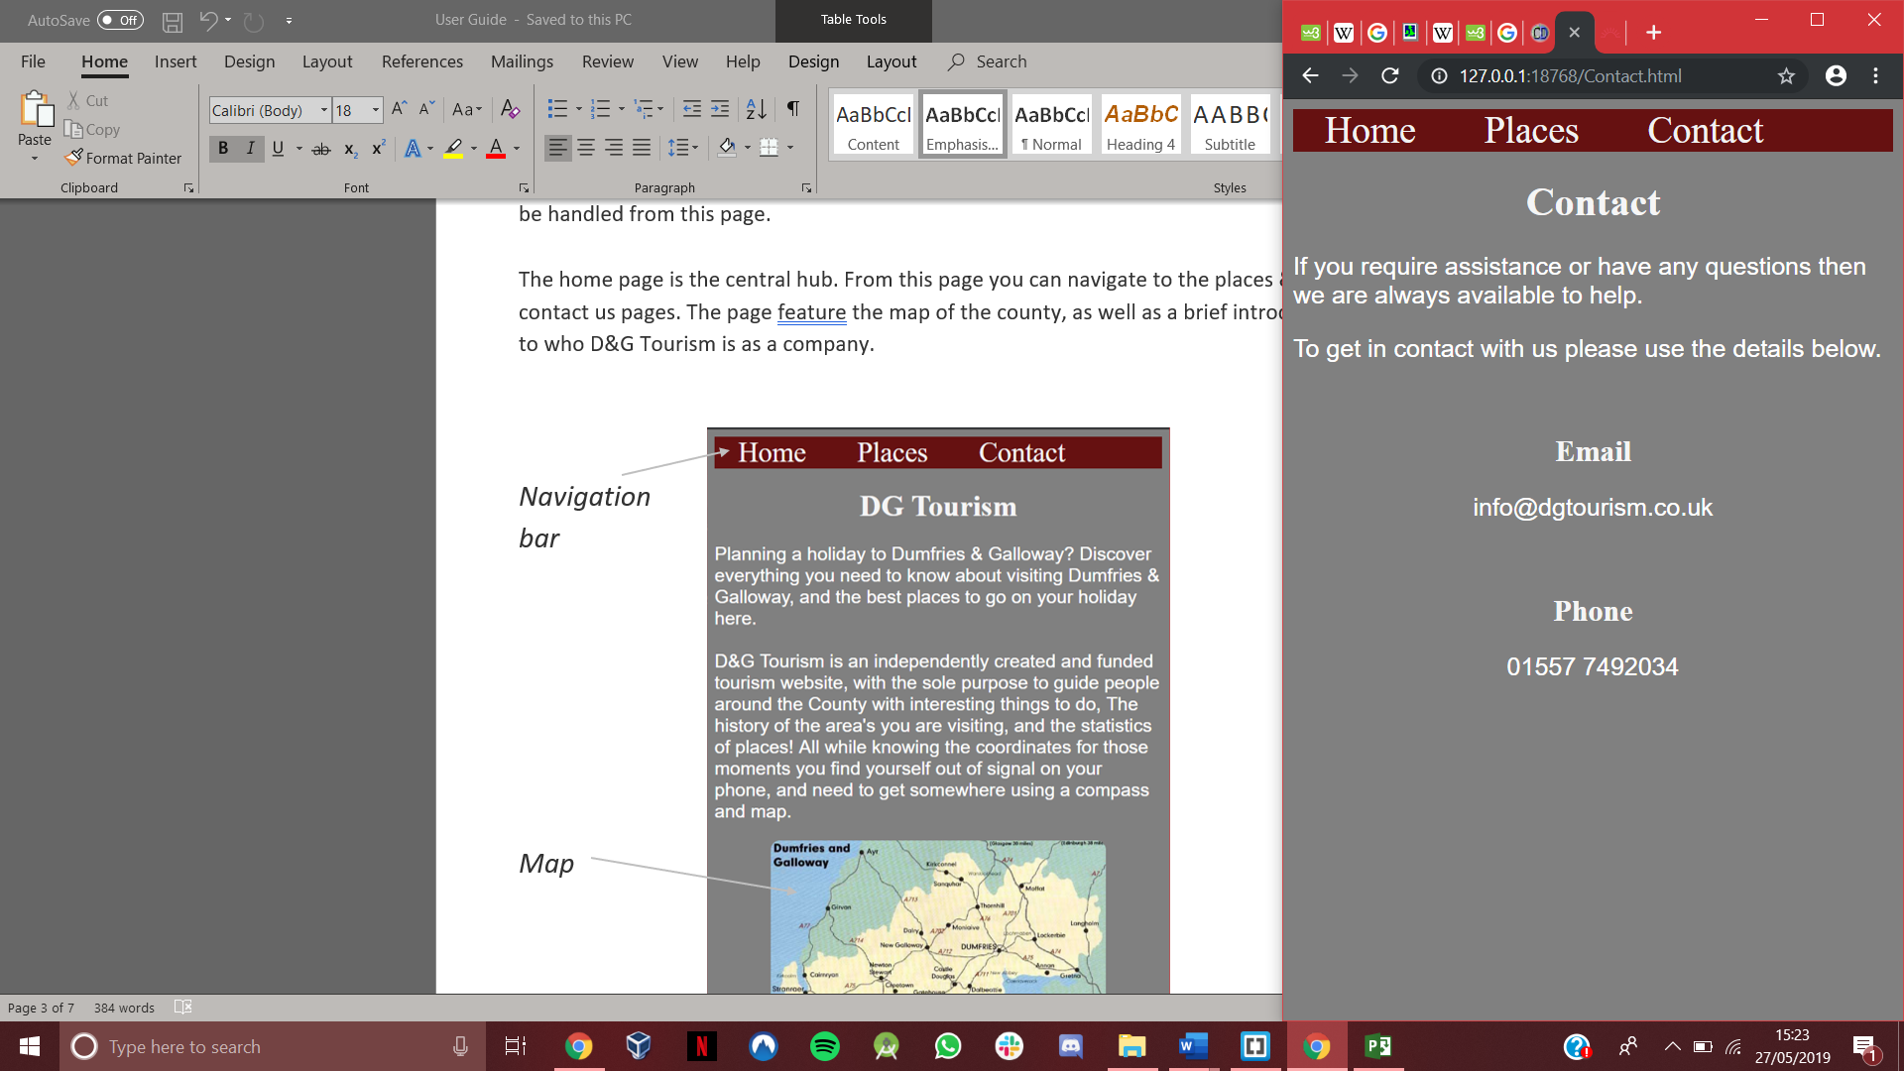

*Navigation*

*bar*

*Contact details*

Any issues?

If you do find you have any issues with the website, them feel free to email me at:

[Human@gmail.com](mailto:Human@gmail.com)

Alternatively, you can attempt to call me at the following number:

01234 567890